Name
Institution
Date

Object property and object state
An object state is a value that is associated with the object run spaces and it ideally can change during the simulations rerun time, for example, the ModelEntity.Priority whose priority changes as the entity is processed, a ModelEntity.Picture whose picture at different stages of the entities change, a server1.InputBuffer.Contents.NumbersWaiting etcetera.
Oject property on the other hand is a value associated with object instances although they do not change as the simulation time evolves. Examples include the ModelEntity.InitialPriority which is set at the initiation of the run, it’s a property that cannot change. Another example is a Server1.InitialCapacity.
- Consider a process associated with a Server object. What is the difference between a token’s parent object and its associated object?
In a simio simulation, tokens execute the processes.
The token is taken as a temporal object that is created in each simio process, having a parent as well as an associate temporal object that which share information within the nodes. This means that in a model entity that visits a server, the server is the parent object and model entity is the latter or associated object.
- Develop a queueing model that gives the steady-state values analogous to the values in Table 5.2. Utilizing the following metrics inside the experimental design:
Placement utilization (Pp) – Placemement.Processing.Contents.AverageNumberWaiting
Inspection Utilization (Pi) - Inspection.Processing.Contents.AverageNumberWaiting
Number in system (L) - PCB.Population.NumberInSystem.Average
Time in system (W) - PCB.Population.TimeInSystem.Average
Average # of Good - GoodParts.InputBuffer.NumberEntered
Average # of Bad - BadParts.InputBuffer.NumberEntered
Metric being estimated Simulation
Placement Utilization (ρpρp) 0.667±0.0030.667±0.003
Inspection Utilization (ρiρi) 0.500±0.0030.500±0.003
Number in system (LL) 2.995±0.0032.995±0.003
Time in system (WW) 0.299±0.0030.299±0.003
Average number of “good” parts 9223.760±37.7689223.760±37.768
Average number of “bad” parts 790.200±7.614790.200±7.614
We built the model, see below, and run the simulation. We choose to run model for 1200. We set-up warm-up period to be 200 hours and run 25 repeatitions. The results are summarized in the table below;
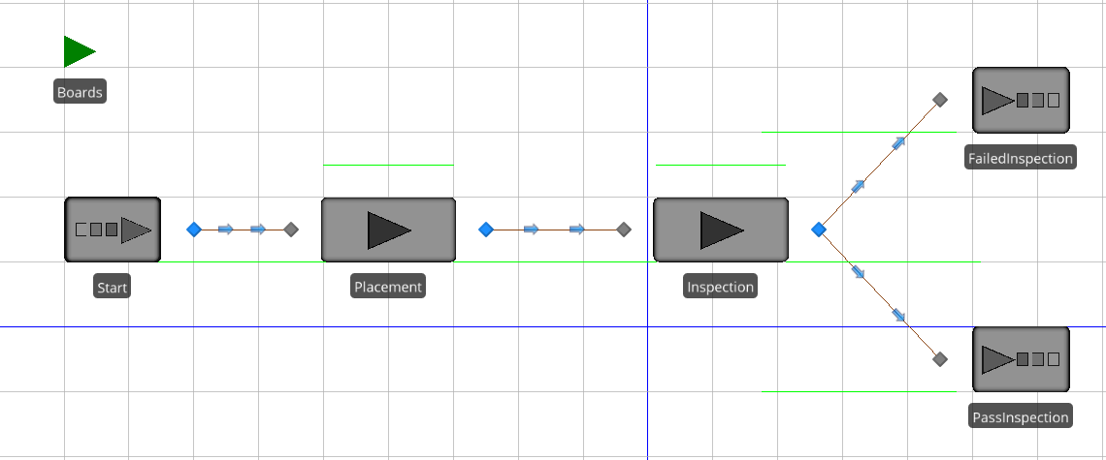
This is the appearance in a model:
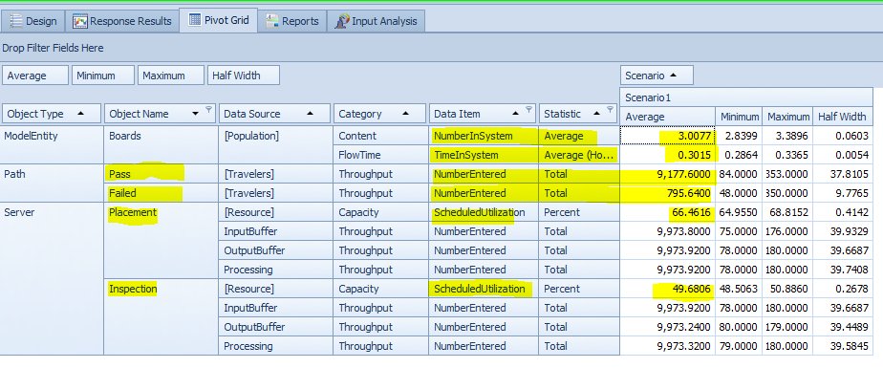

The experiment was then copied and exponential processing times were transplanted into the model.
Placement becomes Random. Exponential (4) & Inspection becomes Random. Exponential (3).
That is:
- The source was pegged to a Rate table, with 6 (assumed poison) arrivals per hours between 9 and 5. Four scenarios were run on 4 different replication inputs. For development purposes, 5 replications is plenty, however upon viewing the comparative Response Results charts, we see that only 25 replications showed all metrics contained within the 95% confidence interval.
Performance is analyzed in metrics:
Time in the system (W) - Customer.Population.TimeInSystem.Average
Reception Utilization (Pu) - Reception.Processing.Contents.AverageNumberWaiting
Vision Utilization (Pv) - Vision.Processing.Contents.AverageNumberWaiting
Written Computer Utilization 1 (Pwc1) - Written1.Processing.Contents.AverageNumberWaiting
Written Computer Utilization 2 (Pwc2) - Written2.Processing.Contents.AverageNumberWaiting
Written Computer Utilization 3 (Pwc3) - Written3.Processing.Contents.AverageNumberWaiting
Reception Queue Avg (LqR) - Reception.InputBuffer.Contents.AverageNumberWaiting
Vision Queue Avg (LqV) - Vision.InputBuffer.Contents.AverageNumberWaiting
Written Computer Queue Avg 1 (LqWC1) Written1. InputBuffer. Contents. Average Number Waiting
Written Computer Queue Avg 2 (LqWC2) Written2. InputBuffer. Contents. AverageNumberWaiting
Written Computer Queue Avg 3 (LqWC3) - Written3. InputBuffer. Contents. AverageNumberWaiting

Representation

What is the difference between an object property and an object state?
Property:
An object property is a set of information that allow user to customize the object behavior. Once an object instance is created in a model, this object property can be modified to ensure that this object will behave in a manner consistent with the object being model. The value of a property is unique to each object instance. However, as the model run, these properties would be the same for each dynamic entities (Run spaces) created. Each type of object have a distinct set of properties (although some are common to all objects). Properties are grouped by categories such as General, Animation, Add-on Process Triggers, and so on. Properties cannot be changed during a run.
State:
A State can be thought of a variable attached to the object instance. State value can be modified as the model run. State can be discrete or continuous in nature. Discrete state can change value on assignment only at discrete point in time Continuous State will change continuously and automatically when its rate (or acceleration) is not zero.

Problem
Process time to process is distributed as:
Application or reception service triangular 5, 8, 11
Vision of school/exam triangular 2, 4, 6
Written exam triangular 15, 15, 20

The office has one person responsible for reception/application and one person responsible for administration of vision exam. The written exam is computer-based and there are 3 computer stations where customers can take the exam.
The office opens from 9:00 AM to 5:00 PM.
We will develop a simio model of this system. We are interested in the following performance metrics:
a] Time customers spend in system
b] Utilization of office employees * Utilization of computer stations
c]Average and maximum numbers of customers in the reception/application queue, the vision exam queue, and the written exam queue
Assumption: I will assume for now that every customer successfully pass the eye and written exam and that there will always be someone attending customers. I am setting work schedule to be 9:00 AM to 5:00 PM without any lunch break.
Please note that we have chosen to represent the 3 computer stations as 3 servers running in parallel each with capacity 1, each with the same distribution and with a routing selection weight of 1 instead of one server with the stated distribution and capacity = 3. We have done so to facilitate the visualization of the layout of the office.
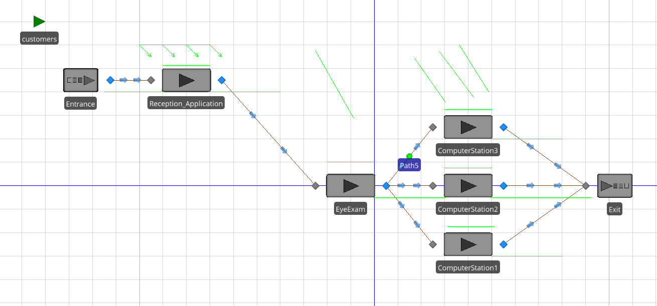

Animation of the model